Resources- Pastas R Us, Inc
University
Instructor’s name
Due date

Resources- Pastas R Us, Inc
Restaurant Speciality- Noodles, Soups and Salads
Number of restaurants where data was collected- 74
Report’s Objective.
The objective of the report is to show the statistical analysis of the variables affecting the chain of 74 restaurants. These factors that are attributed to the success of Pastas R Us, Inc. include the average sales per customer, year-on-year sales growth, sales per square feet as well as the usage of a loyalty card.
Analysis
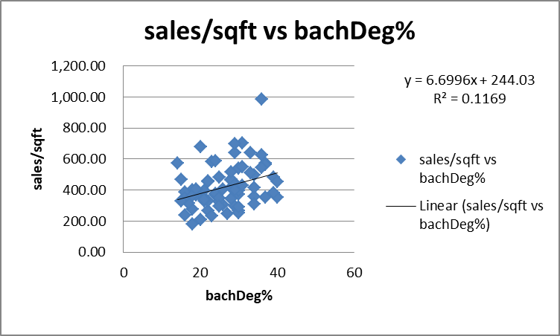
0.341947 | The two variables have a correlation coefficient of 0.341947and therefore have a positive relationship

The introduction of a loyalty card by the marketing department to increase sales by offering a meal to a client who has purchased 10 meals is proving not to be practical as sales have been gradually decreasing. The relationship between the loyalty card and the growth of sales is said to be negative as the two variables have a correlation coefficient of -0.2968. This can be made better by increasing the number of meals a client has to order before getting a free meal at the restaurant.
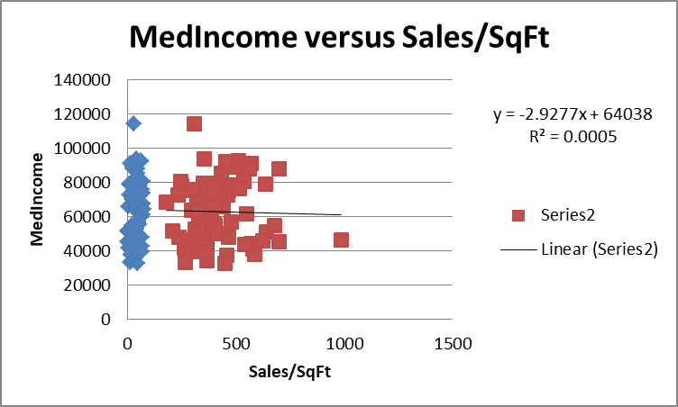
-0.02244 | The two variables have a correlation coefficient of -0.02244 and therefore have a negative relationship

The expansion in sales per square feet has a negative relationship with both the median age and the median income. The median income has a correlation coefficient of -0.02244 with the restaurant’s sale per square feet while the median age has a correlation coefficient of -0.05979 with the restaurant’s sale per square feet. However, the relationship between sales per square feet and bachDeg% is positive since the two variables have a correlation coefficient of 0.341947.
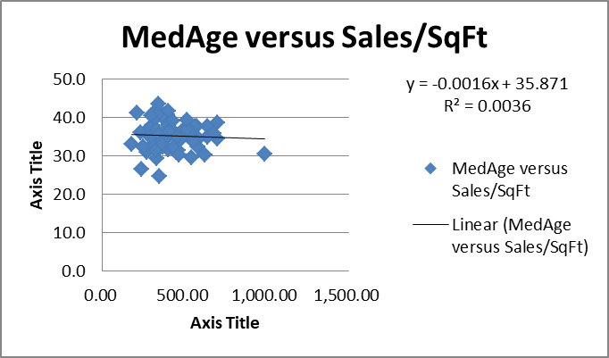
-0.05979 | The two variables have a correlation coefficient of -0.05979 and therefore have a negative relationship

Expansion will run more smoothly if the median income being targeted is lowered and the demographic is increased from mostly the 15% college educated adult population. This is bound to increase the sales of Pastas R Us, Inc.
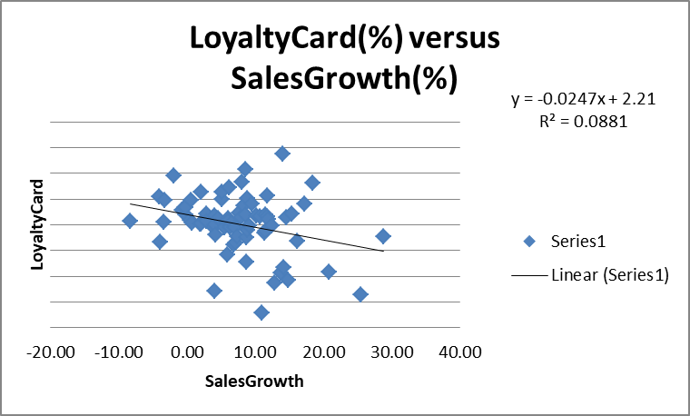
-0.2968 | The two variables have a correlation coefficient of -0.2968 and therefore have a negative relationship

Recommendation
The customers should be enticed by a changing diet and therefore what is on the menu should constantly be evolving. Food development is key. Food combinations and variations that are slow moving should be removed (Clippinge, 2017). The period an average client spends in a restaurant should go hand-in-hand with the time it takes to prepare the meals on the menu. Pastas R Us, Inc. should seek the best way to improve task proficiency and cost enhancement. The technique they choose to use should rotate around the menu with food like noodles, pastas and hot refreshments like soup. There should be more food variations as their income is generated from food deals.
Different channels to order meals could help identify the various avenues of generating revenue. This could be accelerated by putting up deals depending on the channel being used to order food. The channels could vary from online deals, walk-ins, disconnected deals. This could provide important information on which channel is performing admirably and the reasons thereof (Bateh & Wachsmuth, 2015). The business volume will be better with every single online deal being closed as the edges might become lower with every commissioned online deal.
The chain of restaurants should hold on to the deal that costs them the least when it comes to how much is being paid per square feet per annum and get the board to find better ways of acquiring new spaces in ways that will bring the return-on-investments and consistently be on the development direction.
Online deals are likely to appeal to the youths who mostly are already appealed to by the menu of the restaurant and are more consumers of the internet as well. The online platform will give it a competitive edge. Additionally, food advancements should be uploaded on the website for more reaction and feedback from the clients.
Other different advancements include giving out food vouchers, such as getting a bowl of soup for free for every plate of noodles purchased. Happy hours when the prices have been reduced to encourage more walk-in clients especially during the busy hours could be introduced. This could be an important metric in increasing the number of orders being made provided the food aggregators will have inbuilt mechanisms on the number of clients who have placed orders and their preferred meals.
The traffic on the website could also be analyzed to get the information as to why some clients visited the site but failed to execute. This could be because of the value of the meals, the complexity of the website, the content on the menu and so forth. A remarketing procedure should be underway to ensure that such clients interact with the website more freely. Web traffic can also help in identifying the patterns of clients when they are on the site and such information can help better the services being offered on the site.

References
Bateh, J., & Wachsmuth, B. G. (2015). Using Statistics for Better Business Decisions.
Clippinger, D. (2017). Business Research Reporting. Business Expert Press.

